**React & Discover: A Chemistry Exploration Hub**

**Project Description:**

**React & Discover** harnesses the capabilities of the Groq API to deliver an engaging chemistry exploration experience, featuring comprehensive information on elements, creative compound suggestions, and detailed descriptions of chemical reactions. By analyzing user inputs, the platform provides tailored insights that empower users to deepen their understanding of chemistry and enhance their learning experience.

Built with Flask, React & Discover offers a user-friendly web interface that simplifies navigation and interaction with complex chemical concepts. The integration of intelligent AI ensures that the information and suggestions provided are both relevant and insightful, enriching the overall educational journey.With a strong emphasis on secure API key management and the careful handling of user data, React & Discover aims to foster a safe and informative environment, enabling users to explore the fascinating world of chemistry with confidence.

**Scenario 1:** A user inputs an element symbol to receive detailed information about the element, including its properties, uses, and significance. This tailored information enhances user understanding and appreciation of the element's role in various chemical contexts.

**Scenario 2:** A user specifies two elements and requests suggestions for possible compounds. The platform generates a list of compounds that can be formed from those elements, fostering creativity and curiosity in chemical synthesis and encouraging users to experiment with different combinations.

**Scenario 3:** A user requests a description of a reaction between two compounds, and the system provides a detailed explanation of the chemical interaction, including the reactants, products, and reaction conditions. This feature aids in deeper comprehension of chemical processes and enhances the educational experience.

**Scenario 4:** A user queries the estimated costs of producing a specific compound. The platform calculates and provides a transparent cost estimation, helping users understand the practical implications of their chemical experiments and decisions.

### 

### 

### Technical Architecture:

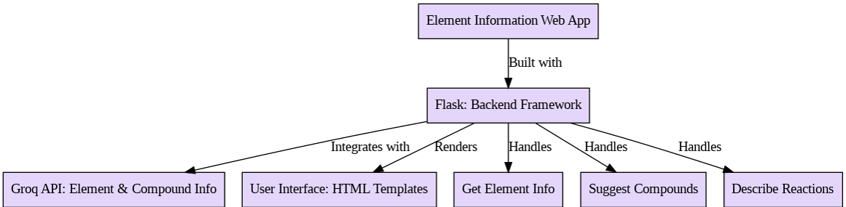

**Pre-requisites:**

### Flask Framework Knowledge: <https://pypi.org/project/Flask/>

### Groq API Familiarity: <https://console.groq.com/docs/quickstart>

### HTML, CSS, and JavaScript Skills: <https://www.w3schools.com/html/html_css.asp>

### Python Programming Proficiency: <https://www.w3schools.com/python/>

### Version Control with Git: <https://git-scm.com/book/ms/v2/Getting-Started-About-Version-Control>

### Development Environment Setup: <https://flask.palletsprojects.com/en/stable/installation/>

### 

### 

**Activity 1: Model Selection and Architecture**

* **Activity 1.1:** Research and select the appropriate generative AI model from Groq for chemistry content generation.
* **Activity 1.2:** Define the architecture of the application, detailing interactions between the frontend, backend, and Groq API integration.
* **Activity 1.3:** Set up the development environment, installing necessary libraries and dependencies for Flask and the Groq API.

**Activity 2: Core Functionalities Development**

* **Activity 2.1:** Develop core functionalities, including fetching element information, suggesting compounds based on user input, and describing chemical reactions between compounds.
* **Activity 2.2:** Implement the Flask backend to manage routing and user input processing, ensuring smooth API interactions for the above functionalities.

**Activity 3: App.py Development**

* **Activity 3.1:** Write the main application logic in app.py, establishing routes for element information retrieval, compound formation suggestions, reaction information description, and cost estimation (if applicable).
* **Activity 3.2:** Integrate AI responses within the routes, ensuring accurate and timely data delivery.

**Activity 4: Frontend Development**

* **Activity 4.1:** Design and develop the user interface using HTML, CSS, and JavaScript, ensuring a responsive and intuitive layout for users to interact with complex chemical concepts.
* **Activity 4.2:** Create dynamic templates with Flask's render_template to display results

based on user interactions, enhancing user engagement and understanding.

**Activity 5: Deployment**

* **Activity 5.1:** Prepare the application for deployment by configuring the server environment and ensuring all dependencies (Flask, Groq API, etc.) are correctly installed and functional.
* **Activity 5.2:** Deploy the application on a suitable hosting platform (e.g., Heroku, AWS) to make it publicly accessible to users.

**Activity 6: Conclusion**

* **Activity 6.1:** Test the deployed application for functionality and user experience

### Milestone 1: Model Selection and Architecture

In this milestone, we focus on selecting the appropriate generative AI model from Groq for our chemistry exploration application. This involves researching the capabilities and performance of various models that Groq offers, ensuring that the chosen model aligns well with our application's objectives of providing comprehensive information on elements, suggesting creative compounds, and describing chemical reactions.

#### Activity 1.1: Research and Select the Appropriate Generative AI Model

* **Understand the Project Requirements:** Review the specific needs of the React & Discover application, focusing on the types of content it will generate (element information, compound suggestions, and reaction descriptions).
* **Explore Groq’s Model Documentation:** Visit the Groq documentation to examine the various generative AI models available, including their functionalities, strengths, and limitations.
* **Evaluate Model Performance:** Compare models based on metrics such as response quality, speed, and relevance to chemistry-related queries. Take note of user reviews or case studies that highlight performance.
* **Select the Optimal Model:** Choose the generative AI model that best meets the application's needs, such as "gemma2-9b-it" for element information retrieval and "llama-3.2-11b-text-preview" for compound suggestions and reaction descriptions.

#### Activity 1.2: Define the Architecture of the Application

* **Draft an Architectural Diagram:** Create a visual representation of the application architecture, including components like the frontend (HTML, CSS, JavaScript), Flask backend, and Groq API integration.
* **Detail Frontend Functionality:** Outline how users will interact with the application through a

user-friendly interface. Identify key input forms for element queries, compound formations, and reaction information requests.

* **Outline Backend Responsibilities:** Specify how the Flask backend will handle incoming requests, process user input, and communicate with the Groq API to generate the necessary chemistry content.
* **Describe AI Integration Points:** Define how and when the application will make API calls to the Groq models. Describe how the backend will receive and handle responses from the AI models to return to the frontend.

#### Activity 1.3: Set Up the Development Environment

* **Install Python and Pip:** Ensure Python is installed on your machine along with pip, which is required for managing dependencies.

1. **Create a Virtual Environment:** Set up a virtual environment using venv to isolate project dependencies:  
   bash  
   Copy code  
   python -m venv react-discover-env
2. react-discover-env\Scripts\activate # For Windows
3. **Install Flask:** Use pip to install Flask and any necessary extensions:  
   bash  
   Copy code  
   pip install Flask
4. **Install Groq API Client Library:** Install the Groq library using pip to interact with the Groq API:  
   bash  
   Copy code  
   pip install groq

* **Set Up Application Structure:** Create the initial directory structure for the React & Discover application, including folders for templates, static files, and main application files (e.g., app.py).

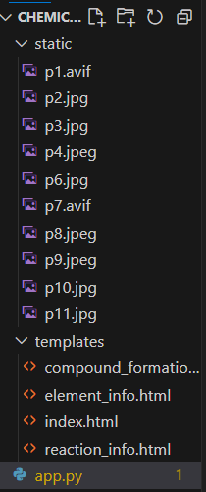

#### Activity 2.1: Develop the core functionalities:

#### Implement the get_element_information function in app.py to fetch comprehensive information about a chemical element based on user inputs like the element symbol. Utilize the Groq AI model to provide structured and relevant output, enhancing the user's understanding of the element's properties and significance.

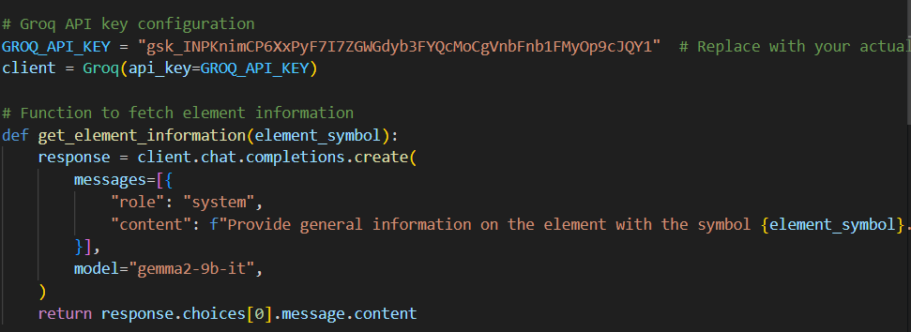

#### To create a function called generate_packing_list that generates a tailored packing list based on the user's destination and season while integrating the Groq API for item suggestions, you'll need to consider the potential compounds related to clothing, gear, and other items based on the destination's climate and activities.

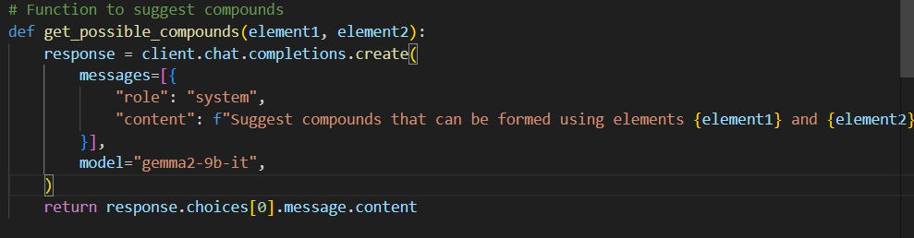

#### The generate_reaction_details function retrieves and presents detailed information about specific chemical reactions based on user queries. It accepts inputs such as reactants and conditions, then utilizes the Groq API to fetch relevant data, including reaction mechanisms, products, and potential yields. The function compiles this information into a structured format, making it easy for users to understand the reaction process.

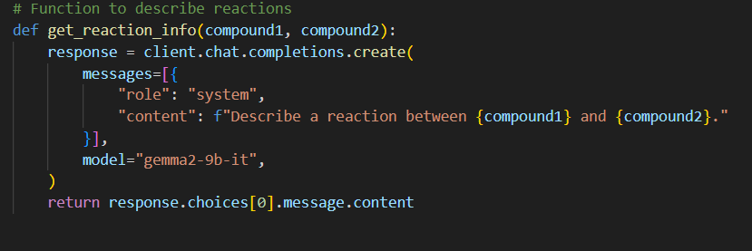

#### 

### Activity 2.2: Implement the Flask Backend for Chemistry Exploration

#### Define Routes in Flask:

Set up routes in app.py for each core functionality, such as **element information**, **compound possibilities**, and **reaction details**. Ensure that each route is linked to the corresponding function developed to retrieve and process information about chemical elements, compounds, and reactions.

#### Process User Input:

Create forms in the HTML templates for users to submit their queries regarding element information, compound possibilities, and reaction details. Use Flask’s request handling capabilities to retrieve data from submitted forms and pass it to the respective functions for processing.

#### Integrate API Calls:

Within each route handler, implement API calls to the Groq API (or use the predefined dictionaries) using the defined functions, ensuring that user inputs are correctly formatted and handled. Capture and manage responses from the API, preparing the data for rendering in the frontend, such as detailed descriptions or visual representations of chemical elements and reactions.

### Milestone 3: app.py Development for Chemistry Exploration Hub

Creating and refining the core logic of the app.py file, which serves as the backbone of the React and Discover application. This milestone involves setting up functionality through Flask routes, establishing reliable user input handling, and conducting unit testing to ensure each feature performs as expected.

#### Activity 3.1: Writing the Main Application Logic in app.py

1. **Define the Core Routes in app.py**
   * Establish separate routes for each of the hub’s core functionalities:
     + **Element Information**: Processes user inputs to retrieve information about specific chemical elements.
     + **Compound Possibilities**: Generates details about available compounds based on user queries.
     + **Reaction Details**: Provides information about specific chemical reactions based on user input.
2. **Set Up Route Handlers for Each Feature**
   * For each route, implement logic that captures and processes user inputs from HTML forms using request.form.get(). This ensures that data is gathered correctly for API calls.

* Example for retrieving element details:  
  python  
  Copy code

@app.route('/element-info', methods=['POST'])

* def get_element_details():
* element_name = request.form.get('element_name')
* details = fetch_element_details(element_name) # Call to the function that interacts with the data
* return render_template('element_details.html', details=details)

1. **Integrate the Groq API Responses in Each Function**
   * Implement function calls within each route to leverage Groq’s API (or the existing data structures) based on user-provided details. For instance, in get_reaction_details(), fetch the necessary reaction information.
   * Ensure each response from the API is processed to enhance readability and is displayed clearly to the user in the appropriate HTML templates.

Home Route:  
 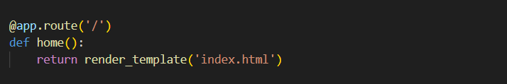

Element Info Route:  
 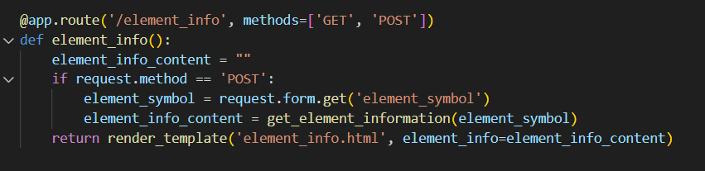

Compound formation Route:  
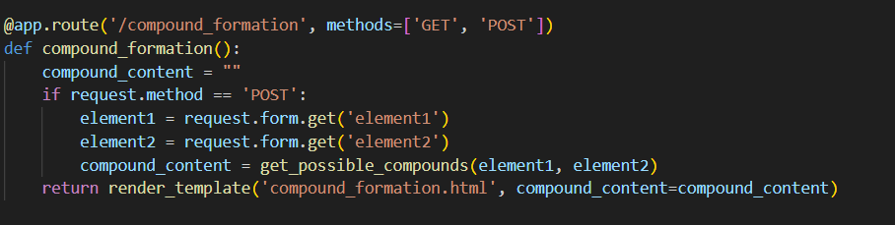

Reaction Route:

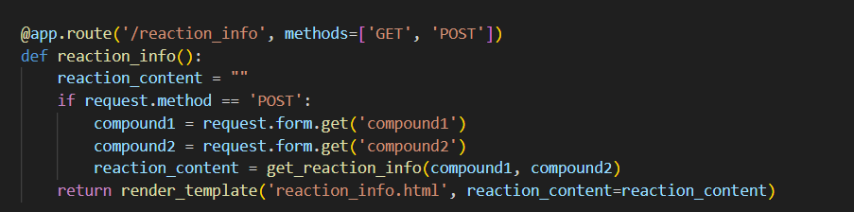

### Milestone 4: Frontend Development

Developing a user-friendly and visually appealing interface for React and Discover. This involves designing the layout with responsive HTML, CSS, and JavaScript to enhance usability and creating dynamic templates with Flask’s render_template function to display personalized chemistry information and other features based on user interactions. This milestone ensures a smooth and engaging user experience, making it easier for users to access and enjoy the core functionalities of the hub.

#### Activity 4.1: Designing and Developing the User Interface

1. **Set Up the Base HTML Structure**
   * Develop a main HTML file (e.g., index.html) that serves as the entry point, including a header, footer, and navigation menu for easy access to the hub’s core features (element information, compound possibilities, and reaction details).
   * Use semantic HTML elements to keep the structure organized and ensure the interface is accessible for all users.
2. **Design a Responsive Layout Using CSS**
   * Create a CSS stylesheet to handle layout and styling, ensuring the design is visually appealing and adjusts seamlessly on various screen sizes (desktop, tablet, mobile).
   * Use a grid or flexbox layout to organize content effectively, and add media queries to handle responsive adjustments across different devices.
3. **Create Separate Pages for Each Core Functionality**
   * Set up distinct HTML templates for each of the hub’s main features (e.g., element_info.html, compound_possibilities.html, reaction_details.html) to present outputs in a clean and organized format.
   * Ensure each page includes user input forms and displays AI-generated recommendations effectively.

#### Activity 4.2: Creating Dynamic Templates with Flask's render_template

**1:** **Integrate Flask’s render_template for Dynamic Content Rendering**

* In each route function in app.py, use Flask’s render_template to render templates dynamically based on user inputs and AI-generated responses. This keeps the interface adaptive and provides personalized content on each page.

Example:

Element Info Route:  
 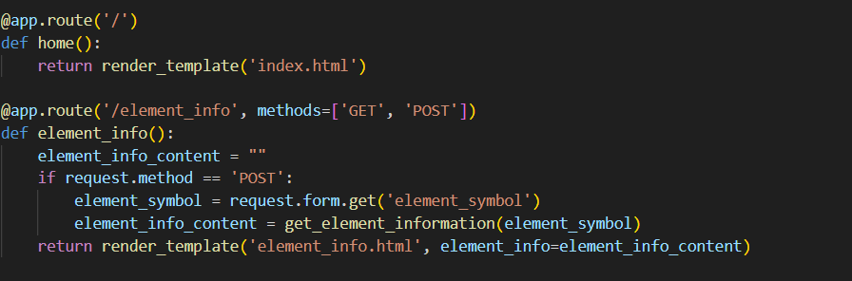

**Step 2:** **Bind Backend Data to HTML Templates**

* Bind data from backend functions to HTML templates using Jinja syntax (e.g., {{ variable_name }}), allowing the app to display generated results, such as the itinerary details, packing lists, or recommended activities, directly within the user interface.

### Milestone 5: Deployment

**In Milestone 5, the focus is on deploying the React and Discover application on a local system using Flask. This involves configuring the server environment, ensuring all dependencies are installed, and launching the app locally to simulate a real-world setup. This milestone helps verify that the app can run smoothly in a stable environment, allowing you to fine-tune any functionality before deploying it to a cloud platform in the future.**

#### 

#### Activity 5.1: Preparing the Application for Local Deployment

1. **Set Up a Virtual Environment**
   * Begin by creating a virtual environment to manage dependencies and keep the local deployment isolated from other projects.

Activate the environment and install required dependencies from a requirements file to ensure all packages (Flask, Groq API libraries, etc.) are available for the app to run.  
bash  
Copy code  
python -m venv env

source env/bin/activate # For Windows, use `env\Scripts\activate`

pip install -r requirements.txt

1. **Configure Environment Variables**
   * Set environment variables for sensitive information like the Groq API key. This is especially important for simulating secure deployment practices, even on a local system.
   * In a .env file or directly in your terminal, add configurations for your API keys and necessary environment settings.

#### Activity 5.2: Testing and Verifying Local Deployment

1. **Access the Application Locally**
   * Once running, open a browser and navigate to http://127.0.0.1:5000 to access the app. Interact with each feature, such as element information retrieval, compound possibilities, and reaction details, to ensure everything is functioning as expected.

Home Page:

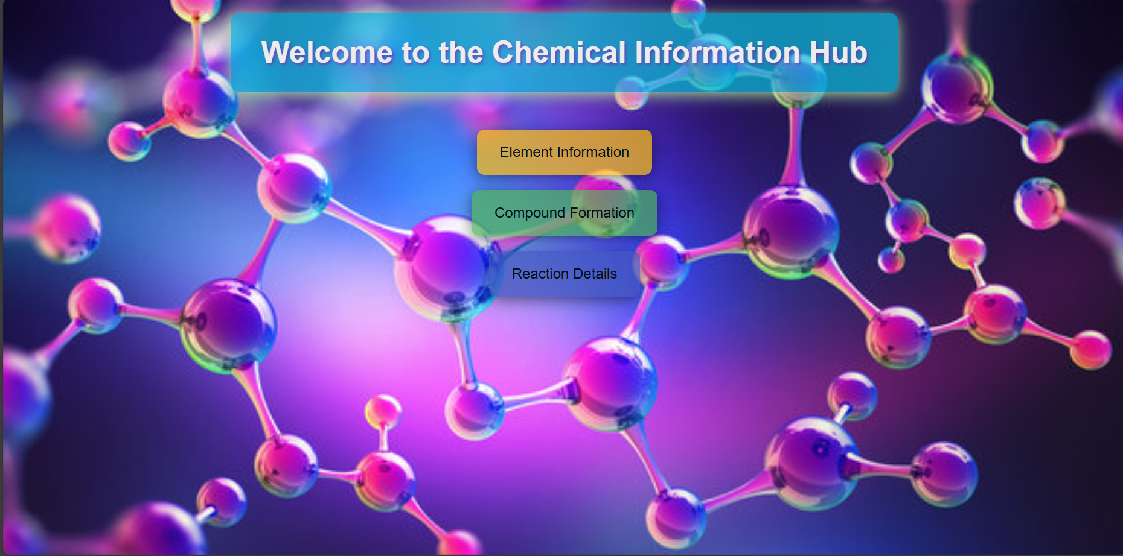

Element Information page:

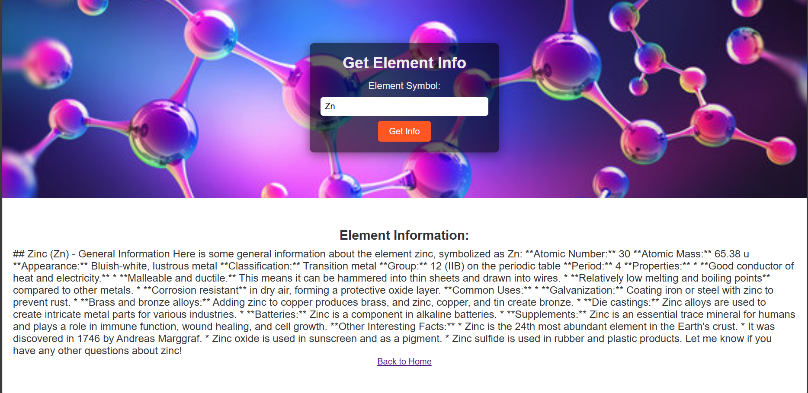

Compound formation:

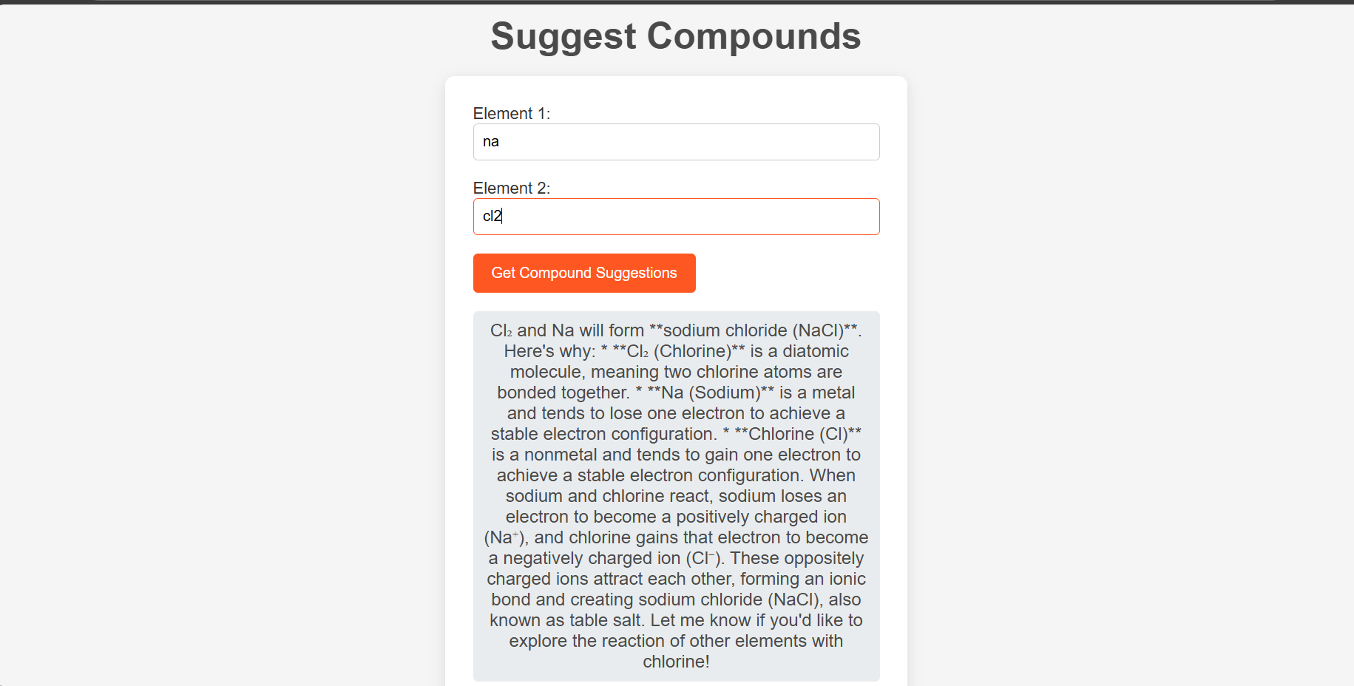

Reaction Details:

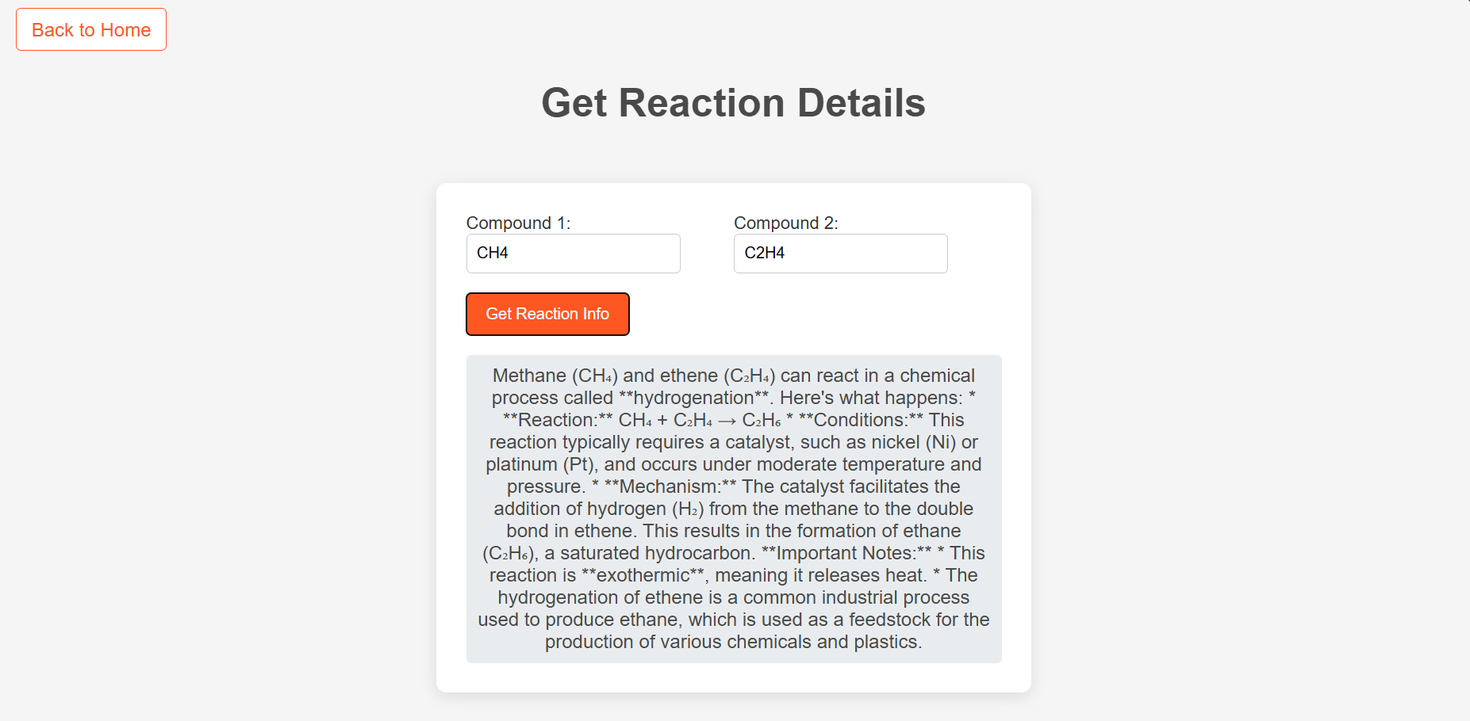

### 

### 

### Conclusion:

The React and Discover project successfully showcases the power of generative AI in transforming the exploration of chemistry into a personalized, streamlined experience. Utilizing Groq's large language models, specifically llama-3.2-11b-text-preview for element information retrieval and gemma2-9b-it for compound possibilities and reaction details, the application generates customized chemistry content that caters to individual user preferences and needs.

By structuring development into clear milestones—including model selection, core functionalities, backend and frontend development, and deployment—the project achieved a responsive, interactive platform. Local deployment using Flask enabled efficient testing and validation of each feature, ensuring a smooth user experience. React and Discover demonstrates how targeted generative AI models and a robust application framework can deliver value by simplifying and enriching the exploration of chemistry, with room for future scalability to broader platforms and more advanced AI capabilities.